STUDENT COORDINATOR—moved signs—3 signs

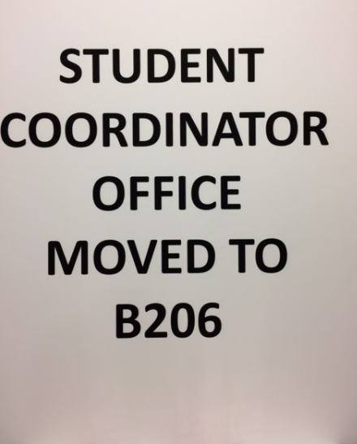

3 signs

